COAL Lab 08 Assignment:

# Name: Owais Ali Khan

# Section: 3-F

# Roll no: 21K-3298

Question # 01:

TITLE Question 1

INCLUDE Irvine32.inc

INCLUDE Macros.inc

.data

source WORD 0,1,2,3,4,5,6,7,8,9

target WORD 10 DUP(0)

.code

main PROC

mov eax, 0

mov esi, 0

mov ecx, LENGTHOF source

mWrite "Source array: "

L1:

mov ax, source[esi]

push ax

call WriteDec

mWrite " "

add esi, TYPE source

loop L1

mov esi, 0

mov ecx, LENGTHOF target

call Crlf

mWrite "Target array: "

L2:

pop ax

mov target[esi], ax

call WriteDec

mWrite " "

add esi, TYPE source

loop L2

call Crlf

exit

main ENDP

END main

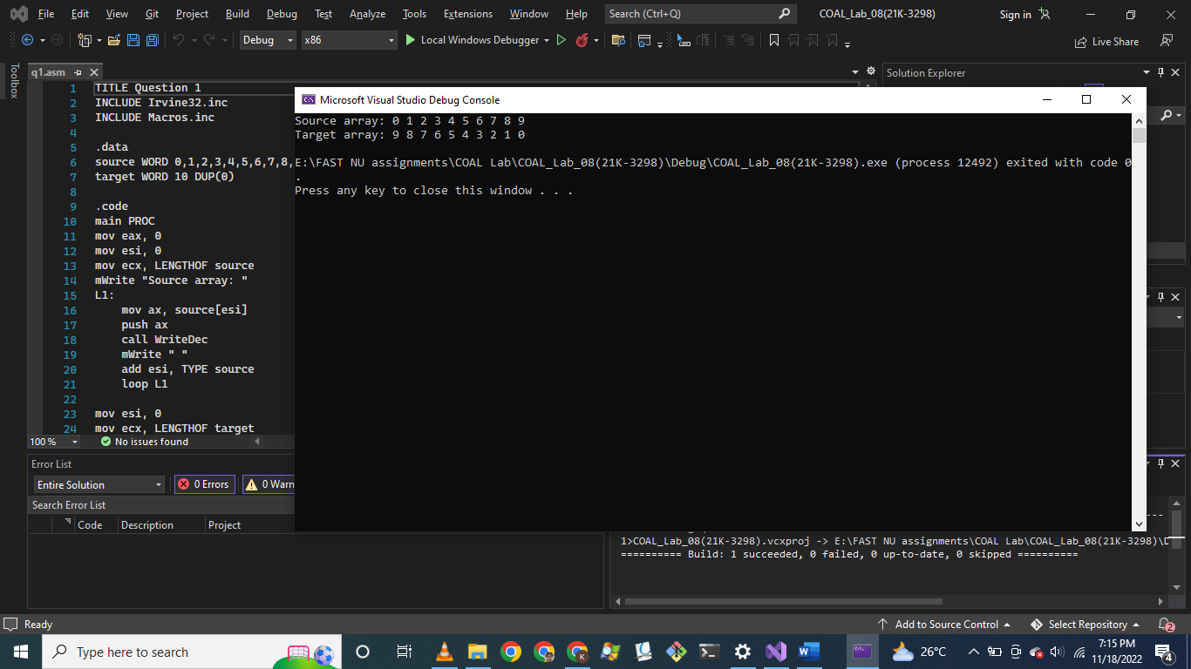

Question # 02:

TITLE Question 2

INCLUDE Irvine32.inc

INCLUDE Macros.inc

.data

array1 DWORD 1,2,3,4,5

array2 DWORD 1,2,3,4,5

.code

main PROC

call Array12Sum

exit

main ENDP

Array1Sum PROC uses esi ; Returns sum value in eax

mov eax, 0

mov ebx, 0

mov ecx, LENGTHOF array1

mWrite "Array 1: "

L1:

add eax, array1[esi]

mov ebx, eax

call WriteDec

mWrite " "

add esi, TYPE array1

loop L1

call Crlf

mWrite "Sum of Array1: "

xchg eax, ebx

call WriteDec

call Crlf

ret

Array1Sum ENDP

Array2Sum PROC uses esi ; Returns sum value in eax

mov eax, 0

mov ebx, 0

mov ecx, LENGTHOF array2

mWrite "Array 2: "

L1:

add eax, array2[esi]

mov ebx, eax

call WriteDec

mWrite " "

add esi, TYPE array2

loop L1

call Crlf

mWrite "Sum of Array2: "

xchg eax, ebx

call WriteDec

call Crlf

ret

Array2Sum ENDP

Array12Sum PROC

mov eax, 0

mov esi, 0

call Array1Sum

call Crlf

mov ebx, eax

call Array2Sum

add eax, ebx

call Crlf

mWrite "Sum of Array1 and Array2: "

call WriteDec

call Crlf

ret

Array12Sum ENDP

END main

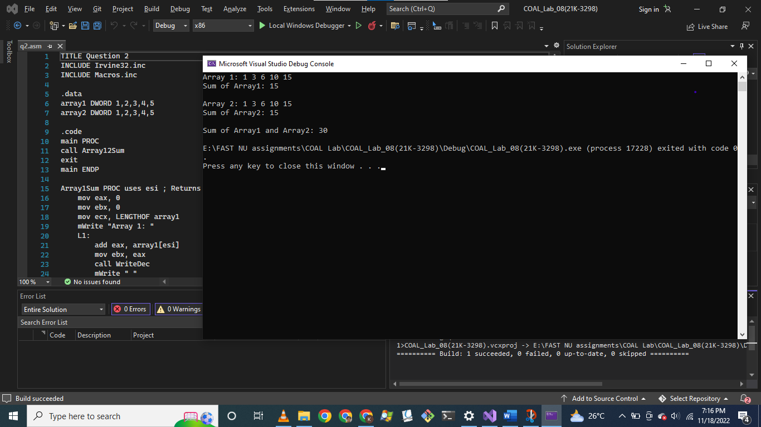

Question # 03:

TITLE Question 3

INCLUDE Irvine32.inc

INCLUDE Macros.inc

.data

columns DWORD 5

.code

main PROC

mWrite "Enter number of columns: "

call ReadDec

mov columns, eax

call Pattern

exit

main ENDP

Pattern PROC ; takes argument from variable "columns"

mov eax, 0

mov esi, 1

mov ecx, columns

L1:

push ecx

L2:

mWrite " "

loop L2

mov ecx, esi

L3:

mWrite "*"

loop L3

add esi, 1

pop ecx

call Crlf

loop L1

ret

Pattern ENDP

END main

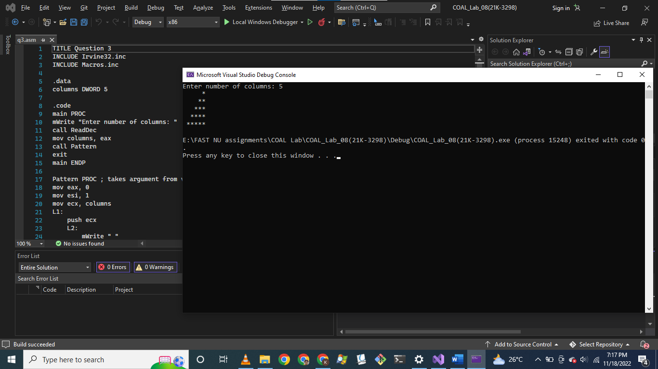

Question # 04:

TITLE Question 4

INCLUDE Irvine32.inc

INCLUDE Macros.inc

.data

character BYTE "A",0

columns DWORD 5

.code

main PROC

mWrite "Enter number of columns: "

call ReadDec

mov columns, eax

call Pattern

exit

main ENDP

Pattern PROC ; takes argument from variable "columns" and "character"

mov eax, 0

mov esi, 1

mov ecx, columns

L1:

push ecx

L2:

mWrite " "

loop L2

mov ecx, esi

L3:

mov edx, OFFSET character

call WriteString

inc character

loop L3

add esi, 1

pop ecx

call Crlf

loop L1

ret

Pattern ENDP

END main

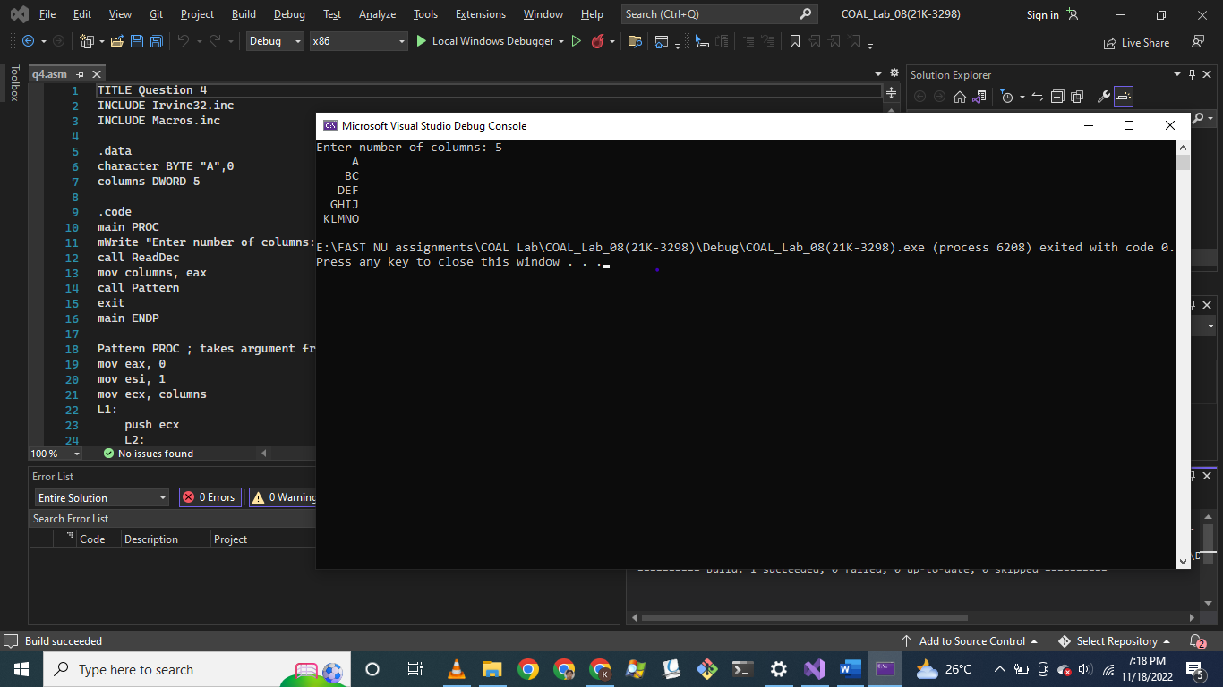

Question # 05:

TITLE Question 5

INCLUDE Irvine32.inc

INCLUDE Macros.inc

.data

n DWORD ?

.code

main PROC

mWrite "Enter value of n: "

call ReadDec

mov n, eax

call Sum

mWrite "Sum of integers from 1 to n is: "

call WriteDec

call Crlf

exit

main ENDP

Sum PROC ; takes argument from variable "n" and returns value in eax

mov eax, 0

mov ecx, n

L1:

add eax, ecx

loop L1

ret

Sum ENDP

END main

